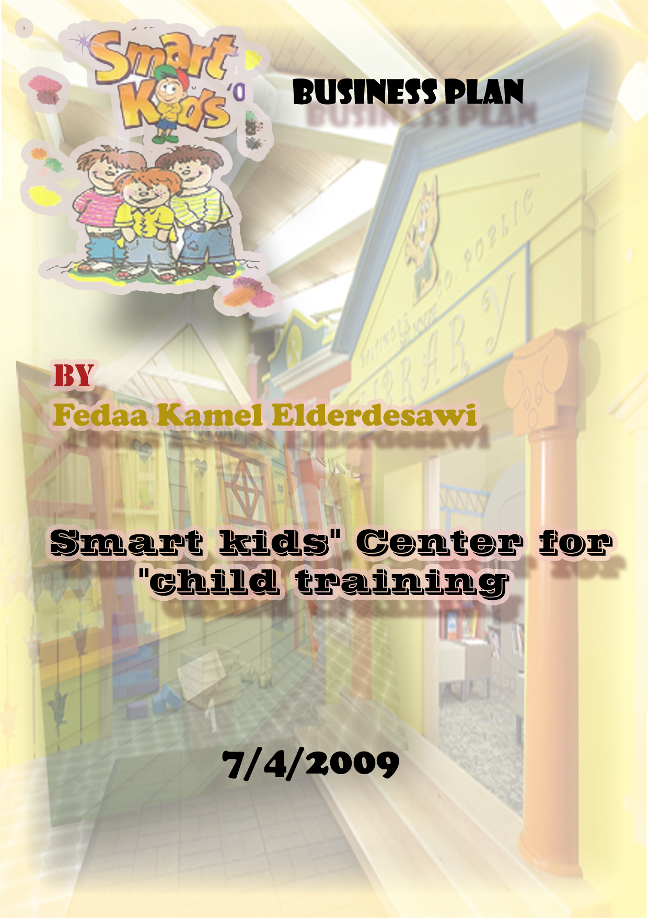
0599667251 –feda_alwatan1@hotmail.com

Table of Contents
I. Table of Contents 2
II. Executive Summary 3
III. General Company Description 4
IV. Services 6
V. Marketing Plan 11
VI. Operational Plan 16
X. Financial Plan 17
XI. Appendices 20

Executive Summary

Smart kids center is a project for talents and creative children who their ages between 4 and 14 years old .The center will be interested in those children and tries to increase their abilities and improves their creativeness by giving them Various creative courses that related to their abilities also it will be provided with different equipment and expert staff that take care of our child Creators.

General Company Description
Smart kid's center will be for children training who are between 4 -14 years to improve their Capabilities and talents in different fields like Computer, Drawing, sound, art , Math and critical thinking .also to provide them good environment for Innovation and excellence.
Our purpose is to create a positive learning environment that is developmentally appropriate and enhances EACH child’s development physically, mentally, socially and emotionally.
At Smart kids center we believe that all children are born to be great thinkers. We encourage creative growth by designing a curriculum that allows each child to contribute in his or her unique way. Our interactive classrooms are filled with science, art, and nature everyday. Students and adults work together in an environment conducive to fostering self esteem and friendship. In a classroom where no child ever fails, we are all a success.

Our project will be target to talented children and Excellent children.

Center Hierarchy

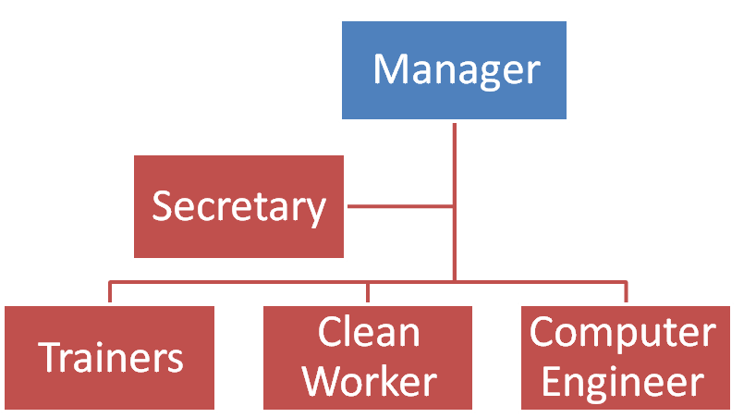

Mission.
- To give high quality service for children and to Creates comfortable and beautiful environment full with Creativity.
- To give children special enrichment if their family cannot provide it.
- To feed our children creativity taste
Our Goals
- Offer the best childcare for our child by offering creative programs and high quality from special training.

- Meet the child's needs by fostering their creativity and uniqueness,

- Discovering and growing the talents of the children.

- Send our letter for the world that our children despite all difficulties and the siege they still be creative and innovative.
- To Facilitate the way towards progress and innovation

Objectives
- Measuring the intelligence level for children.
- Develop child talents.
- Improve the performance of child.
- Increase the capacity of center.

Keys to Success
- Develop creative, educational, training approaches.
- High-quality hourly care and service
- provide a clean, upscale, enjoyable environment conducive to giving professional trusting service
- offer clients a wide range of services in one environment
- Provide an easily accessible location for customer convenience.
- Indoor and out doors activities for year-round entertainment

Services
Our services will be seasonal and depend on the running events
Table 1: price of center activities
Activities | price($) for one child
Member friend in Smart kids | 5
Courses in Photoshop | 30
Courses in drawing& painting | 35
Courses in designing | 30
Courses in MS office | 30
Drawing by computer | 35
Courses in flash | 20
Courses in printmaking | 30
Courses in sport | 15
Courses in Math | 10
Courses in photographing | 15
Courses in writing | 10
Plays theater training | 25
Smart kids magazines | 3
Courses in Safety | 15
Critical thinking courses | 10
Smart kids Future | 10
To be creative | 15
Be positive child | 10
Develop kids talent | 10
Team building courses | 10
Crafts | 12
leadership courses | 10
Science courses | 15
Celebrations | 2.5
Trips | 8
Summer camps(1 month) | 50
Smart kids festival | 2.5
Creative games | 15
To dream | 15
Exhibitions | 3
Special days | 3
Fun Foods for Kids | 10
Success Stories | 8
competition for best story | 5
Kids Birthday Party
Tour round the books | 8
Electronic Cultural competition
Folded Competition | 2
1-Courses in drawing and paintings
Children work together and collaborate to create a themed design collection which will be showcased at the end of a set course by preparing exhibition to show all children projects. In our classes children will learn about key elements to successful design just as a real professional designer would in a fun and friendly environment.

All the different art materials for all projects are included in the cost of a lesson. The kids will work with a professional artist who will teach and help the children to do projects that a “real” artist might do - such as: drawing from observation or imagination, exploring techniques using
different art materials (watercolors, acrylics, oil pastels charcoal, printmaking, collage, and/or clay or wire sculpture.
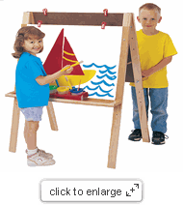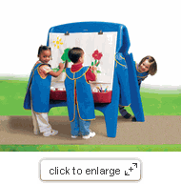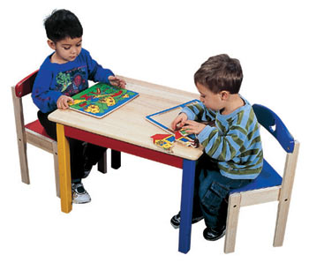
2-Creative Writing Course
Creative Writing Course for Young Writers, which be enthusiastic for young writers who want feedback on their writing and a chance to learn more about the writing and editing processes. Quite often these young writers are not sufficiently encouraged in their writing at school, and parents are frustrated when it becomes apparent that there are far too few creative writing courses available for their talented child.
Students undertaking the course will be encouraged by their tutor to enter writing competitions and to submit their work to magazines for publication.

3-Acting (Drama)
They are taught core drama skills and are encouraged to use their imagination, singing develops their voices and rhythm.

4-Work shops
Lectures from local experts and discussion groups on topics related to raising young children (i.e. parenting skills, nutrition, child development).

5-Creative mathematics
This topic provides preparation of the children for different approach in acquiring math content, creating simulative environment for implementing math’s activities and implementation of math’s games and activities.
6-Creative science
The workshop emphasizes scientific research for early childhood education. The starting point is the need of observation and creating environment. Through creative activities children are encouraged to classify, compare, observe, measure, communicate, recognize and estimate
7-Trips
Smart kid's center will conduct several Recreational trips to beautiful places that children like it also it conducts scientific trips for learning.
8-Summer camps
Smart kids will prepare for number of creative and exciting summer camps for talents children and it will be full with different training and entertainment programs
9-Exhibitions and child festivals
Smart kid's center will hold child exhibitions and festivals for all people to show the creativeness of talents children from Various sides like: sound creativeness, computer creativeness, writing creativeness, Acting, sport creativeness, science, Math, painting, drawing and designing
10-Smart kid's magazine
Smart kids magazine will be published seasonally and it will talk about the most important works for the center also it will include the latest news and creativeness of our children in different fields
Smart kids library
Children's Library is a reading room for children. The following are available for children:
- Computer terminals for children to search books
- Children's books that have long been popular and study references on the open shelves: picture books, stories, and science books
- Library staff to answer children's questions and tell stories for the children on request.
The room provides children with materials on the geography, history, religion, science and regions in the world, picture books and storybooks, and books written in foreign languages.
Capacity of center
The capacity of center is depended to the area of the place so it is assumed that the place is 500 m square and the departments on it are:
Computer lab which contains 20 computers and other Accessories.
- Library which contains desks ,chairs ,bookcases ,video and computer
- Workshops room for special training
- Training room which has capacity for 20 trainers
- Drawing and design room also has capacity for 15 trainers
- Theater room
- Management room
The center will start work daily from 9 AM till 5 PM that means 8 hours daily so the work in the center will be in schedule for allowing more children who came for training or just visited the center in order to increase the capacity of the center.
By assuming that the center will approve 70-90 child at one hour and that number will repeated each two hours on the same working day .Then the number of kids visitors will reach approximately 280 to 360 kids daily according to the schedule of work and training courses through the day
By the time assume that the children who come on the second day will not be the same persons who come on the first day and that will increase from the capacity of the center

Marketing Plan
Market summary
Smart Kids services will introduced to Gaza children who aged between 4 and14 that mean from Kindergartners to elementary schools. From Ministry of education statistical the number of Kindergartners and elementary school students was in (2007) 415456 students.
Our center will be for talented, smart, Special and Creator children so we want to apply tests for samples from total number of children and accept special ones in these tests. Also according to the capacity of center that determined before as the capacity of center that will reach 100 children at the same time and 400 at the same day, 800 on two days so the market share will reach 19% to 23% from the total number of children.
Our Target markets are:
- Kindergartners
- Elementary school students

Market research

Market research should be made to study the market of all needed services for our target group by using surveys, focus groups for the children and meetings with experts.
After that we take in to account the result of this research when we want to establish with the project.
Market needs
The need for place that takes care of the talents child and tries to improve or develop their creativeness.

3.4 Customer's interests
Each kind of talented children has different intelligence, thinking and wants so the need to make Intelligence tests to know the levels of intelligence and how to deal with these levels to improve them.

Economics

Size of market
Since our target group from children who ages between 4 and 14 so depending to these ages it means that those children in kindergarteners and elementary school
Table Target market segmentation
Elementary school students | 388065
kindergartners | 27391
Total | 415456

By assuming that working hours are 8 hours per day and the capacity of each hour will range between 70 to 90 kids and that number will be repeated every two hours also assume that the second day will have the same capacity of the first day with different kids. So that market share from the target group will range between 13% to 17% from the total number.
Market trends
Every year number of children increase which results on increasing demand to the center and from historical data in ministry of education the figure below show the trends of increasing child in elementary schools.
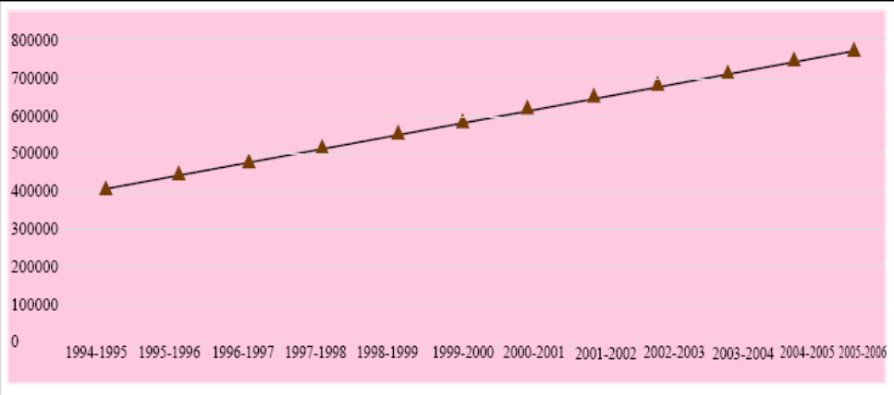
Figure 2: # of children trends through the years before
Forecasting demand
This study plan for one year because the center services will be different from to month so we assume that the demand to center services will increase by 5% each month
Table 3: Demand for Smart kids services
Period | Demand
June | 560
July | 588
August | 617
September | 648
October | 681
November | 715
December | 750
January | 788
February | 827
March | 869
April | 912
May | 958

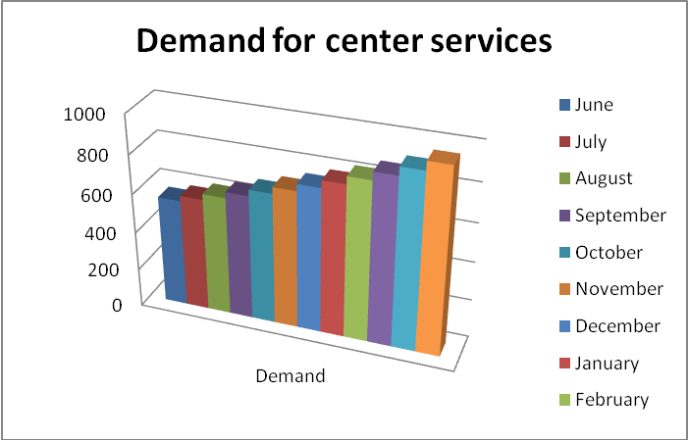

Figure 3: Forecasting demand for smart kid's services

Competition

Unlike our competitors, we offer advanced technology programs, after-school tutoring, and activities such as arts and crafts, theatre and gymnastics, all in one location.
The 2 other factors in our competitive edge are:
- Location: Best location of any child type activity center.
- Service: Equipment and facilities to appropriately entertain the age group

Strategy
The most important criteria in that project is how to market our services in good way which need to make promotion for the center services and to try to build the company name in the market in order our center be well known to every one Gaza.

1.Positioning
Our company will enters the market easily and compete other kids centers by our high quality services , skill trainers , and different creative activities .
So the position for new company in this field will be good.
2.Pricing
Price of our services depends on cost of each activity and the used tools so the price will be high according to high quality given.

3.Promotion

The center services will be promoted in the market through advertisements in: Internet, TV, radio, posters, news papers and by making Festivals through visits to schools and kindergartens.

VI .Operational Plan
Activity | Duration  (Week) | Start date | End date | Duration day
Feasibility study | 2 | 01/04/2009 | 15/04/2009 | 14
Excavation for proper site | 4 | 16/04/2009 | 14/05/2009 | 28
Select one site according to specification | 1 | 15/05/2009 | 22/05/2009 | 7
Making contract to hire the site | 1 | 23/05/2009 | 30/05/2009 | 7
Preparing for Utilities | 2 | 31/05/2009 | 14/06/2009 | 14
Scarring and painting | 2 | 15/06/2009 | 29/06/2009 | 14
Laying tiles | 1 | 30/06/2009 | 07/07/2009 | 7
laying carpet for offices | 1 | 08/07/2009 | 15/07/2009 | 7
Contract with suppliers for making furniture | 3 | 01/07/2009 | 22/07/2009 | 21
Contract with suppliers to provides devices and equipment | 2 | 01/07/2009 | 15/07/2009 | 14
Advertisements for Smart Kids center  service | 5 | 01/07/2009 | 05/08/2009 | 35
Opening & Celebration | 0.5 | 10/08/2009 | 13/08/2009 | 3.5

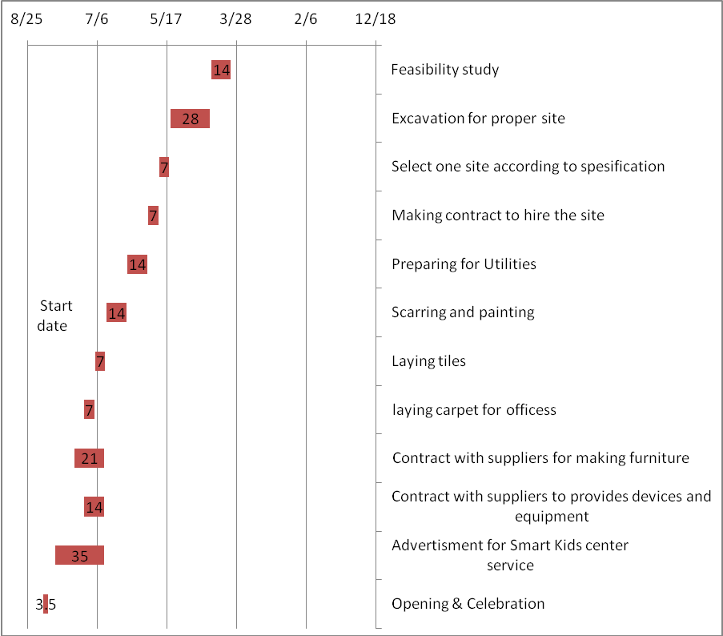
Proposed Location

Location is important for that in order to attracts largest number from our customers also it must be in clean environment with excellent facilities so it suggested to be in Remal Neighborhood

X. Financial plan
Assumptions
- Financial study is studied to 12 months.
- Demand will increase 5% from month to month
- Assume minimum attract rate of return is 15%.

Sales Forecast

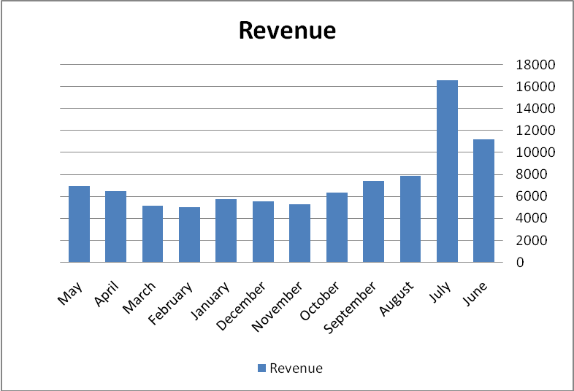

Expenses forecast

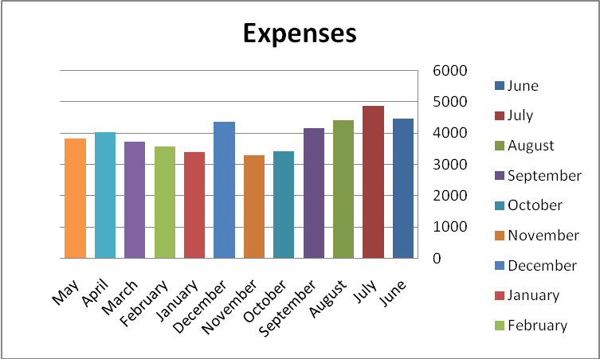

XI. Appendices
Start up cost
Investment cost $
Training for staff | 300 | 300
Computer room assets | 9980 | 9980
Arts room assets | 830 | 830
Theater room assets | 2030 | 2030
Library assets | 2090 | 2090
management room assets | 2090 | 2090
Training and workshops room | 720 | 720
Games room | 1440 | 1440
Painting | 250 | 250
Carpets | 300 | 300
Curtains | 200 | 200
 | $ - | 20230

Balance Sheet
Period | Expenses | Revenue | Profit
June | 4472.75 | 11220 | 6747.25
July | 4882.75 | 16575 | 11692.25
August | 4402.75 | 7875 | 3472.25
September | 4152.75 | 7400 | 3247.25
October | 3422.75 | 6315 | 2892.25
November | 3292.75 | 5280 | 1987.25
December | 4372.75 | 5530 | 1157.25
January | 3392.75 | 5758 | 2365.25
February | 3582.75 | 5028 | 1445.25
March | 3732.75 | 5120 | 1387.25
April | 4042.75 | 6440 | 2397.25
May | 3842.75 | 6910 | 3067.25

Interest rate | 0.15
Period | 13
PW | 3965.54
FW | 24399.14
IRR | 22%

